27.33: a) For minimum magnitude, the angle should be adjusted so that 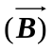 is parallel to the ground, thus perpendicular to the current. To counter gravity, 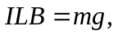 so 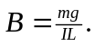
b) We want the magnetic force to point up. With a northward current, a westward field will accomplish this.

